**Reason for delay**

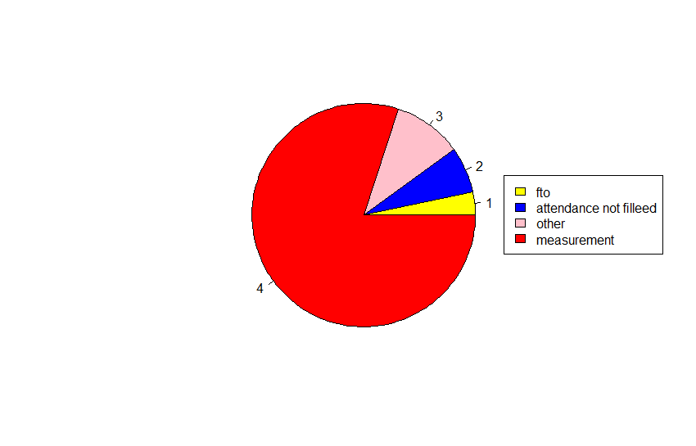

frequencies of reasons of delay

The next data set that we are mining is to find out the reasons of delay. the first figure is a pie chart showing the frequency of each reason. The reasons include Measurement book not being filled in time, Attendance not being signed properly by the workers and fund transfer order delay. Measurement book records the progress of the work on a daily basis by technically qualified officials which on not being filled on time will cause delay in accepting and sending of fund by the government. Attendance book records the presence of the worker on daily basis which on not being filled the government cannot accept the wages. Fund transfer order must be given from higher officials to release the wages which when delayed causes delay of the wage payment.

Evidently the major reason of the delay in the payment of wages is untimely filling of Measurement books. this may be due to neglegence or unavailability of qualified technical persons.

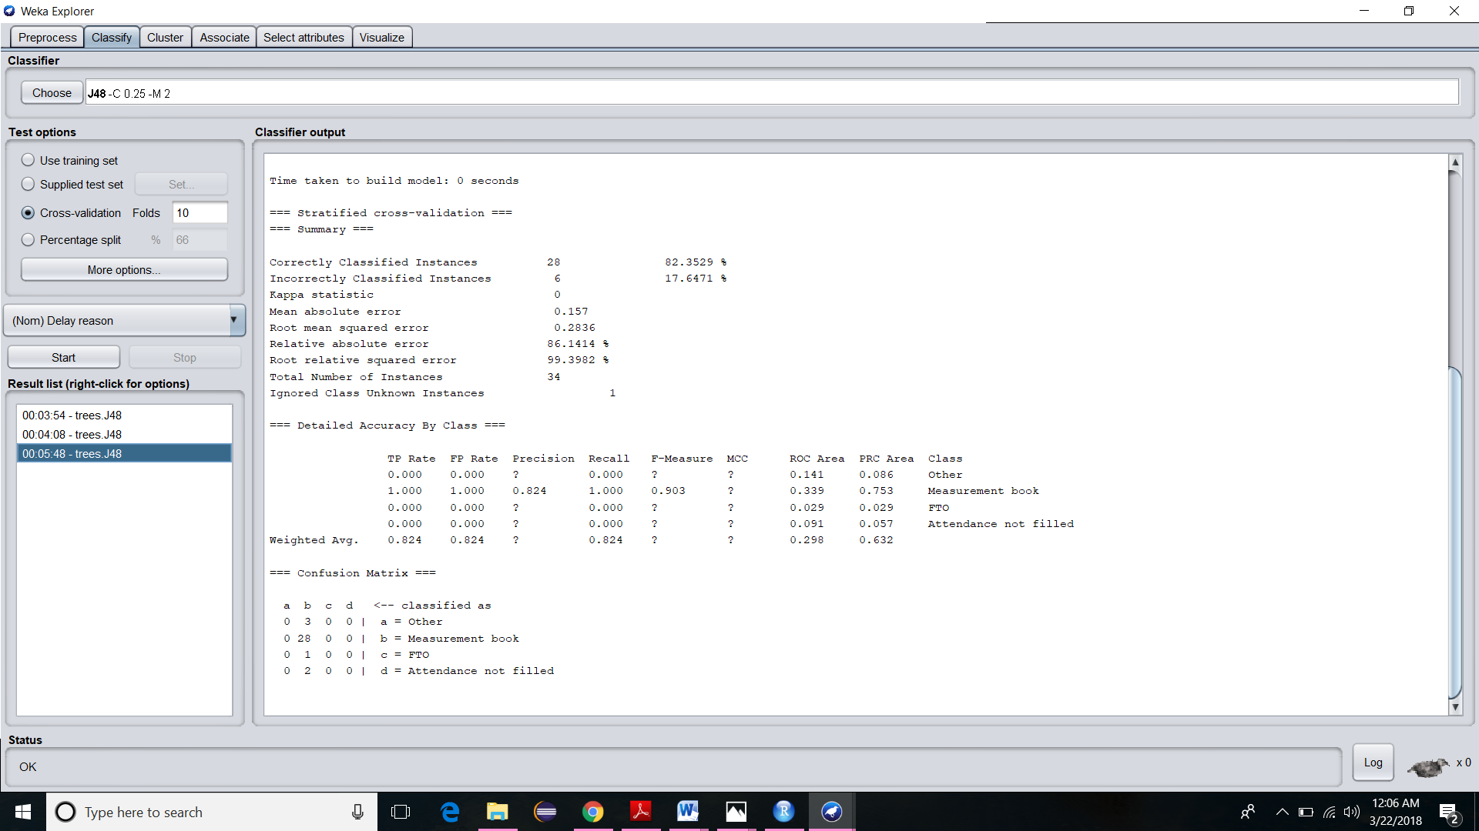

Confusion matrix for classification

The data set on classification using J48 algorithm produces the above confusion matrix. As it clearly understood, Measurement book, FTO, Attendance not filled and Others are the class labels and the states are classified under the respective class labels having frequency 28,1,2 and 3.

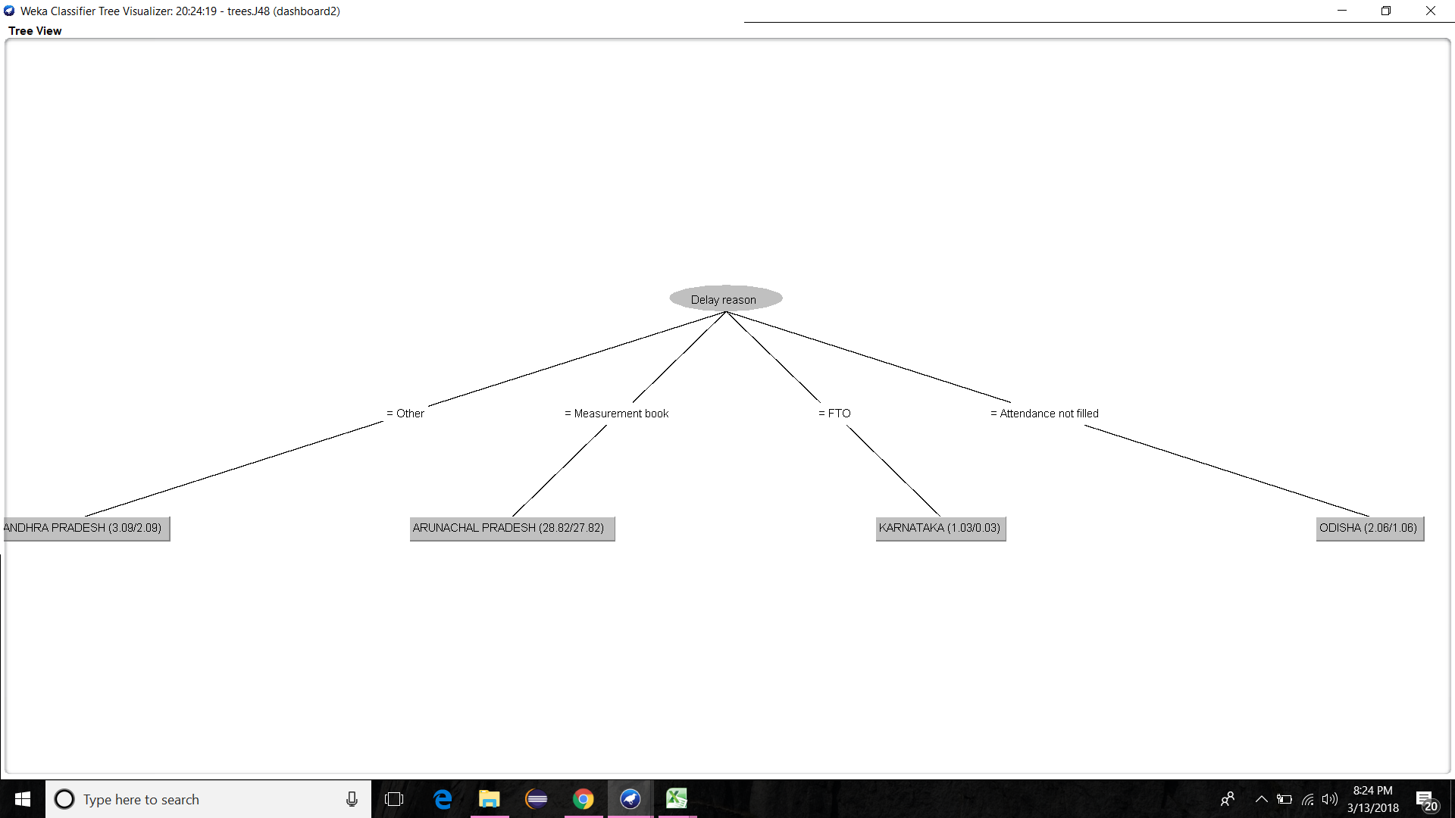

delay reasons classification tree

The classification tree generated while classifying the states with respect to the various reasons for delay is shown above